1. | PIN Verification System  Suppose you want to develop a Personal Identification Number (PIN) evaluation system, which evaluates a PIN entered by the user and tells if the PIN is valid or not. A PIN is considered valid if and only if all of the following conditions are met:  - The PIN must consist of numbers only. No alphabets or special characters are allowed.  - The PIN must be exactly 4 characters long.  - The PIN cannot start with a '0'.  The user will use a standard computer keyboard for input.  Design the DFA required to check the validity of a PIN. Mention Q, Σ, q0, F, and δ. You will need to provide the transition diagram as well.
2. | Sub-Zero’s “Head Rip” FATALITY  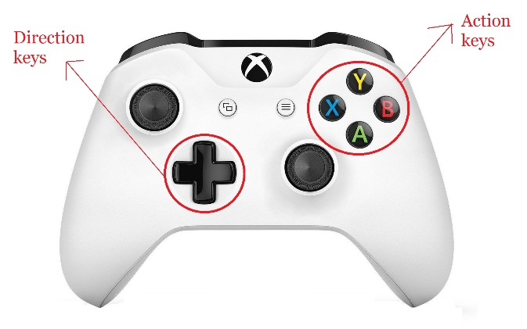  Mortal Kombat is a video game franchise known prominently for its violent fatalities. In the game, each character has their own set of fatalities with each requiring its own distinct input sequence. But for this problem, we will only look at a specific one, Sub-Zero’s “Head Rip” fatality. To perform it, the user must enter the following sequence of inputs exactly: F, D, F, Y. If the user fails to provide the inputs in this exact sequence, the fatality will not be executed.  The user will use a standard Xbox controller like in the picture. The game maps the direction keys of the controller as: Forward (F), Back(B), Down(D), Up(U). The action keys of the controller are the same as in the picture. We don’t have to consider the rest of the buttons.  Design the DFA required to check if the user’s input will execute Sub-Zero’s “Head Rip” fatality. Mention Q, Σ, q0, F, and δ. You will need to provide the transition diagram as well.

